**ASSINGNMENT-3**

**BANKING SYSTEM**

**TASK 1:**

**1.Create database**

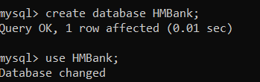

**2.Define schema for customers, accounts, transactions tables**

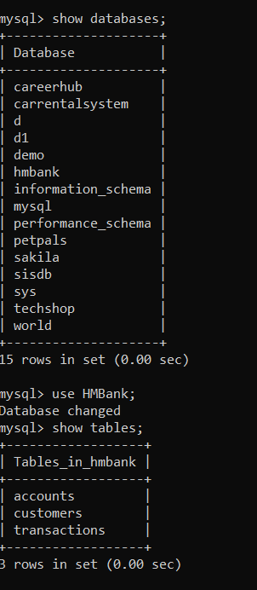

**3.ERD for HMBank**

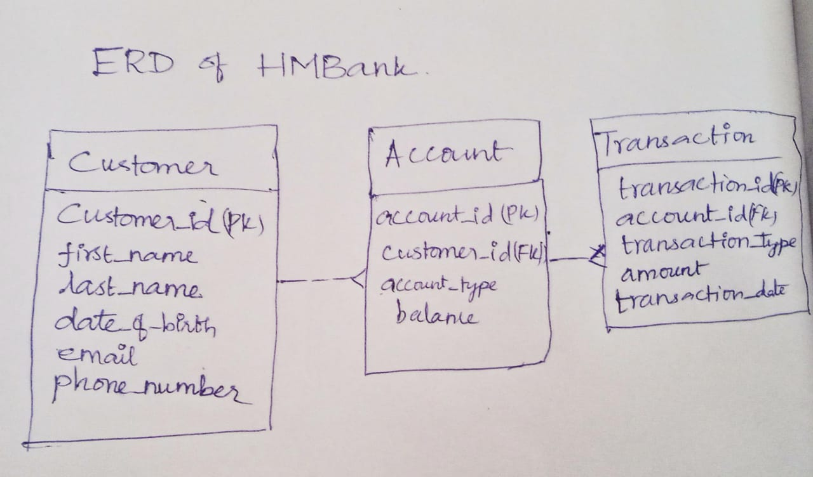

**4.Create appropriate primary and foreign key**

customer_id int primary key

account_id int primary key

transaction_id int primary key

foreign key (customer_id) references Customers(customer_id)

foreign key(account_id) references Accounts(account_id));

**6.SQL SCRIPTS**

Create the Customers table

create table Customers (customer_id int primary key,first_name varchar(50) ,last_name varchar(50) ,DOB date,email varchar(255) ,phone_number varchar(15),city text);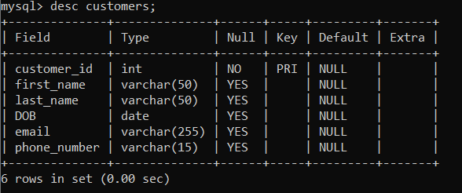

Create the Accounts table

create table Accounts (account_id int primary key,customer_id int,account_type varchar(20),balance decimal(10, 2) ,foreign key (customer_id) references Customers(customer_id));

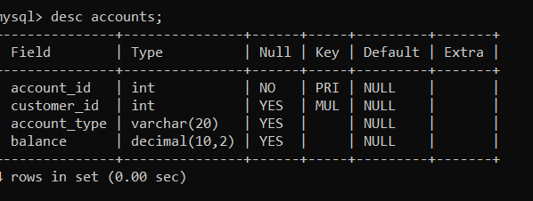

Create the Transactions table

create table Transactions (transaction_id int primary key,account_id int,transaction_type varchar(20),amount decimal(10, 2) ,transaction_date date,foreign key(account_id) references Accounts(account_id));

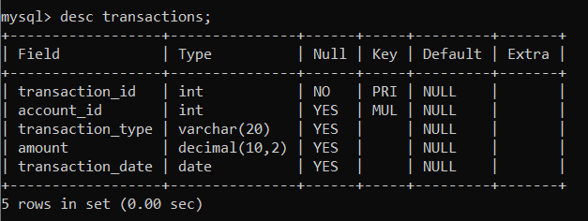

**TASK 2:**

**1.Insert data into these tables**

Insert into Customer table

insert into Customers values

(1, 'Simran', 'Malhotra', '1992-06-08', 'simran.malhotra@example.com', '2109876543','Chennai'),

(2, 'Rohan', 'Saxena', '1997-04-17', 'rohan.saxena@example.com', '1098765432','Salem'),

(3, 'Rahul', 'Bhatia', '1994-05-09', 'rahul.bhatia@example.com', '9876543213','Mumbai'),

(4, 'Aarav', 'Gupta', '1997-08-21', 'aarav.gupta@example.com', '9876543211','Delhi'),

(5, 'Sanya', 'Singh', '1996-05-14', 'sanya.singh@example.com', '8765432110','Covai'),

(6, 'Aryan', 'Mittal', '1998-11-27', 'aryan.mittal@example.com', '7654321109','Chennai'),

(7, 'Ananya', 'Rajput', '1995-03-05', 'ananya.rajput@example.com', '6543210987','Salem'),

(8, 'Karan', 'Sharma', '1994-09-12', 'karan.sharma@example.com', '5432109876','Covai'),

(9, 'Ishita', 'Verma', '1996-07-18', 'ishita.verma@example.com', '4321098765','Delhi'),

(10, 'Ravi', 'Joshi', '1993-01-30', 'ravi.joshi@example.com', '3210987654','chennai');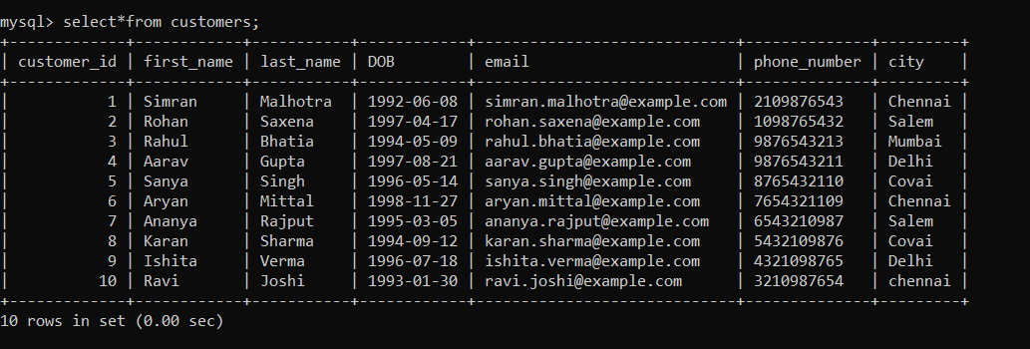

Insert data into Accounts table

insert into Accounts values

(101, 1, 'savings', 5000.00),

(102, 2, 'current', 10000.00),

(103, 3, 'zero_balance', 0.00),

(104, 4, 'savings', 8000.00),

(105, 5, 'current', 15000.00),

(106, 6, 'zero_balance', 0.00),

(107, 7, 'savings', 12000.00),

(108, 8, 'current', 20000.00),

(109, 9, 'zero_balance', 0.00),

(110, 10, 'savings', 0.00);

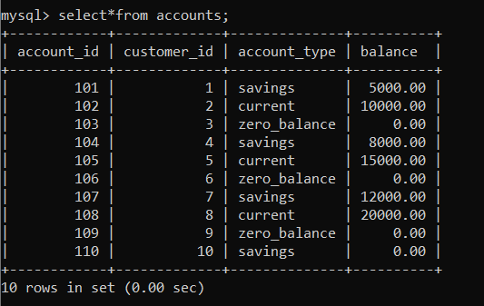

Insert data into Transactions table

insert into Transactions values

(201, 101, 'deposit', 1000.00, '2023-01-15'),

(202, 102, 'deposit', 5000.00, '2023-01-20'),

(203, 104, 'transfer', 2000.00, '2023-01-25'),

(204, 105, 'withdrawal', 1500.00, '2023-01-30'),

(205, 108, 'deposit', 4000.00, '2023-02-05'),

(206, 103, 'withdrawal', 2000.00, '2023-02-10'),

(207, 106, 'transfer', 1000.00, '2023-02-15'),

(208, 101, 'withdrawal', 1500.00, '2023-02-20'),

(209, 107, 'deposit', 3000.00, '2023-02-25'),

(210, 109, 'withdrawal', 1000.00, '2023-03-01');

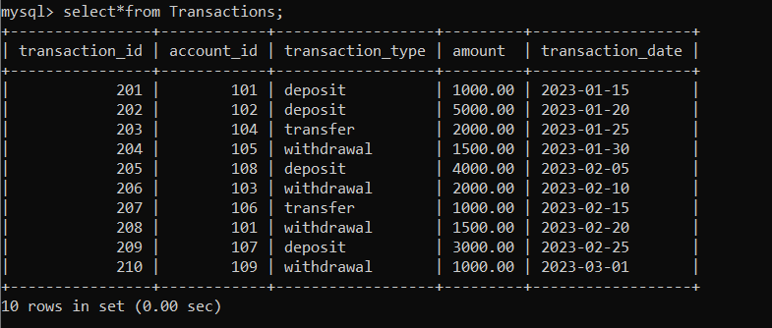

**2.SQL QUERIES**

1. To retrieve the name, account type and email of all customers

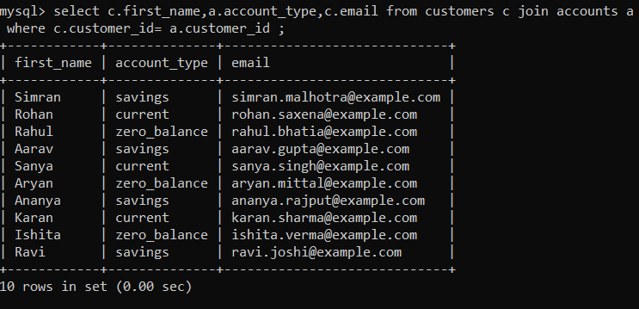

2. To list all transaction corresponding customer

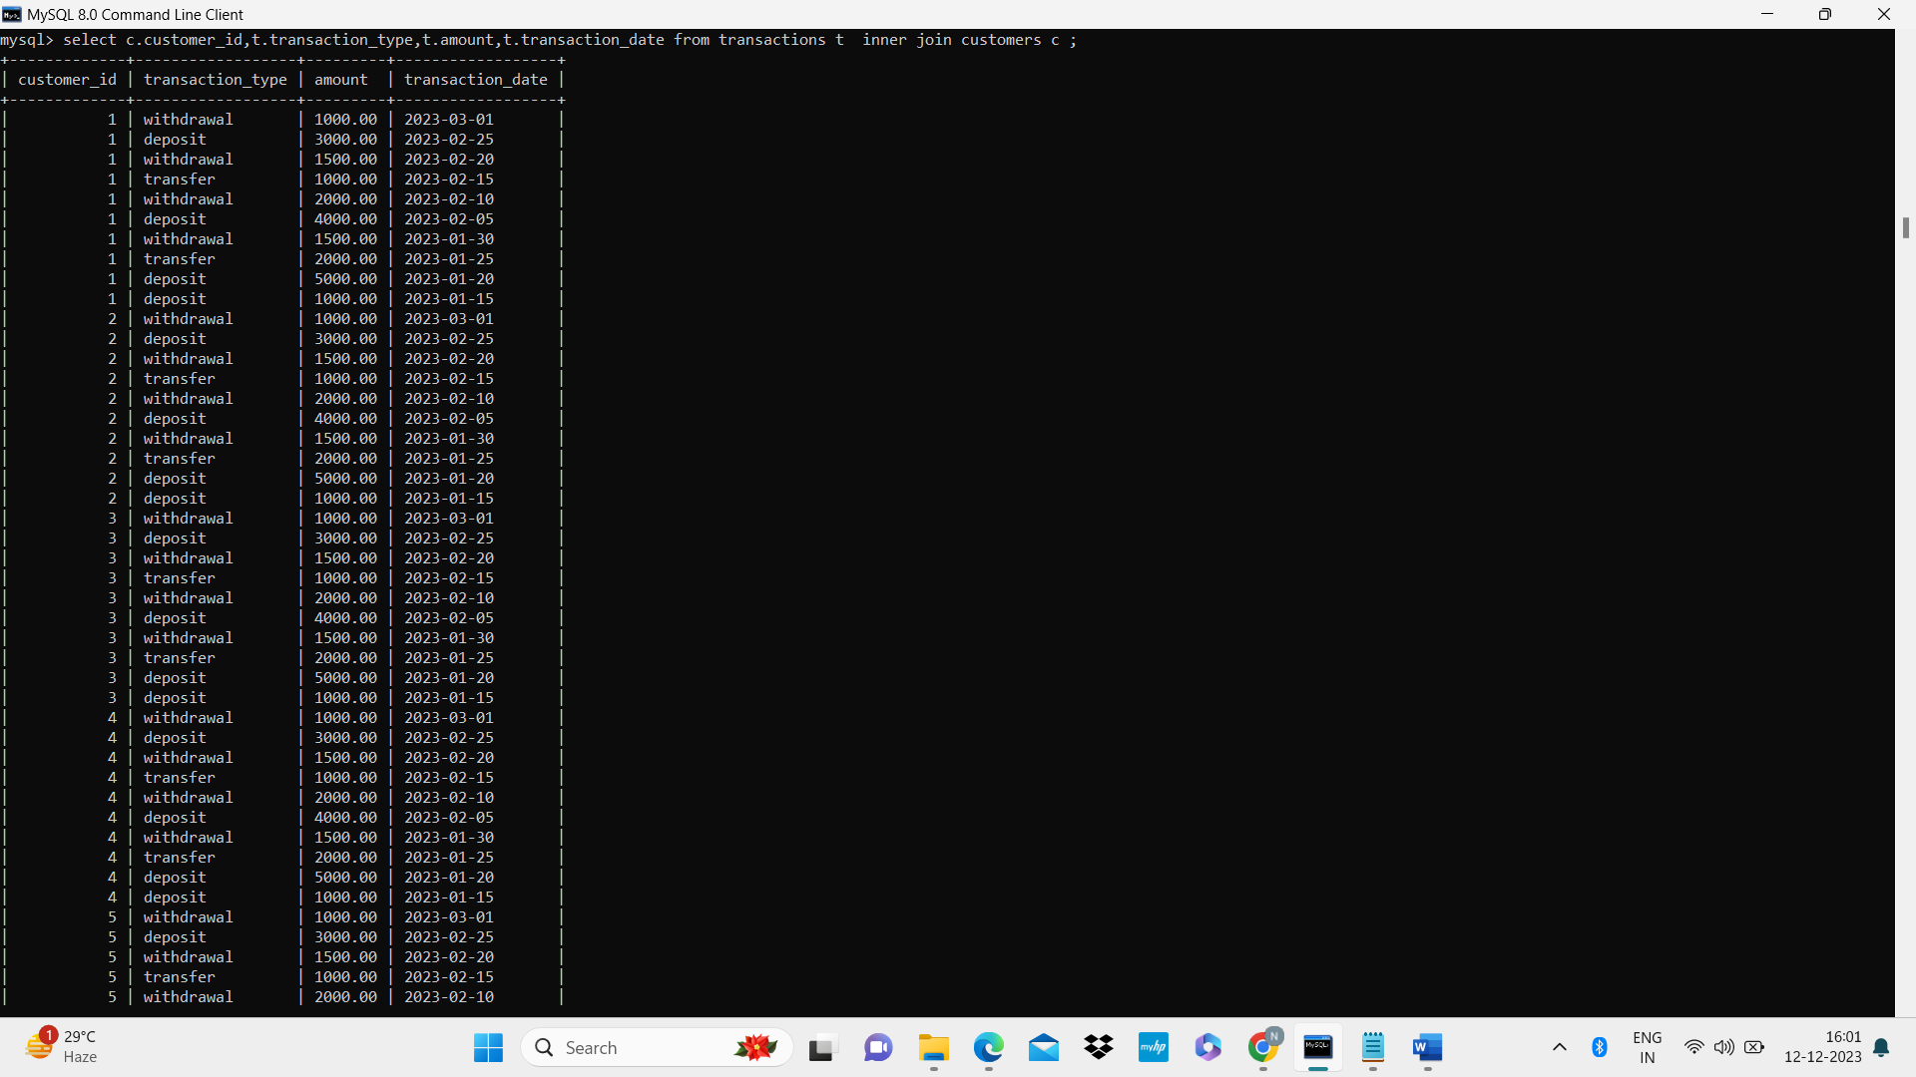

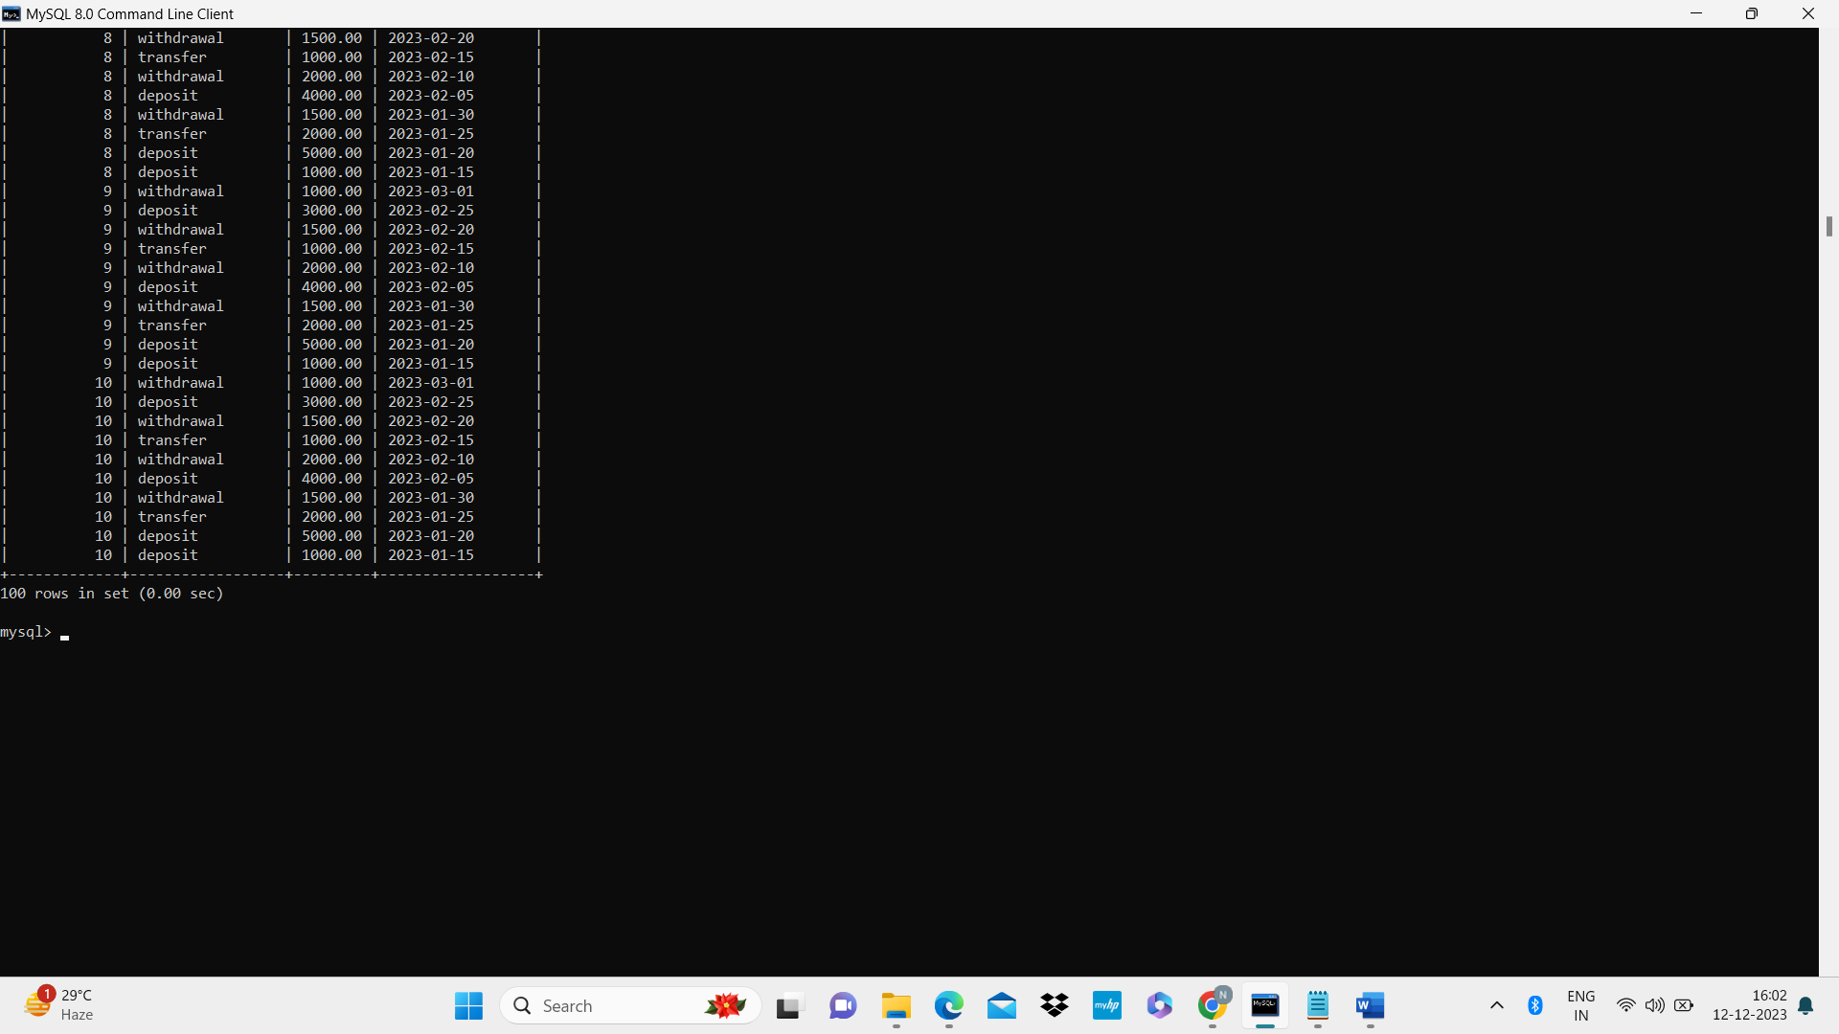

3. To increase the balance of a specific account by a certain amount.

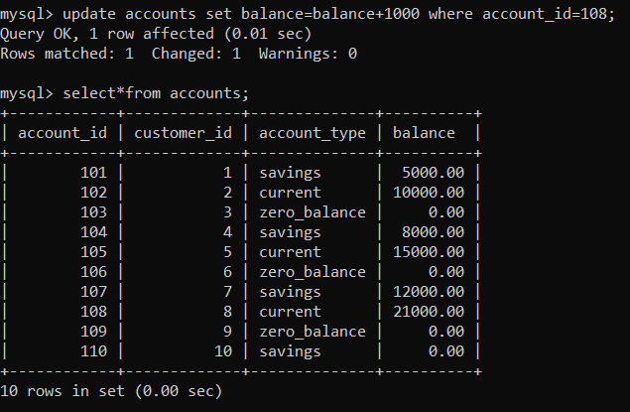

4. To Combine first and last names of customers as a full_name.

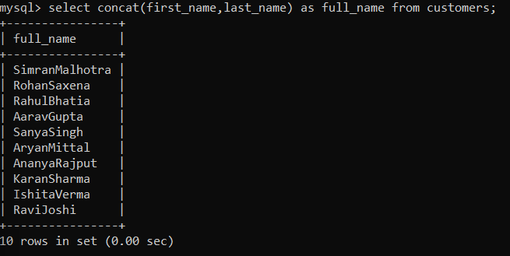

5. To remove accounts with a balance of zero where the account type is savings.

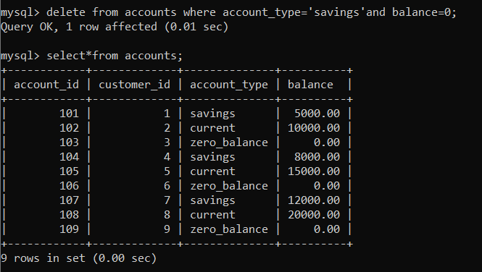

6. To Find customers living in a specific city.

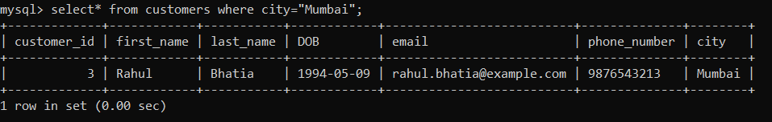

7. To Get the account balance for a specific account.

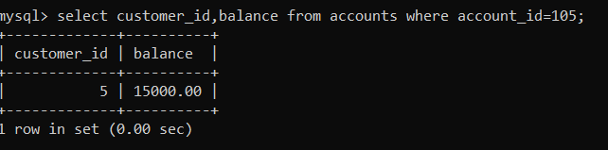

8.To to List all current accounts with a balance greater than $1,000.

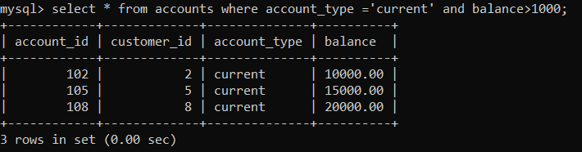

9. To Retrieve all transactions for a specific account.

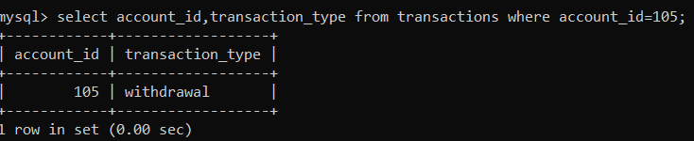

**TASK 3:**

1. Find the average account balance for all customers.

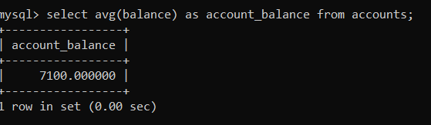

2. Retrieve the top 10 highest account balances.

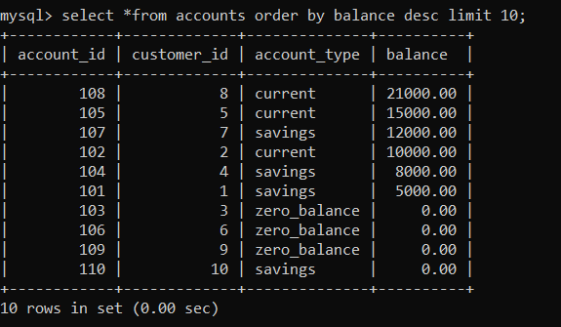

3. Calculate Total Deposits for All Customers in specific date.

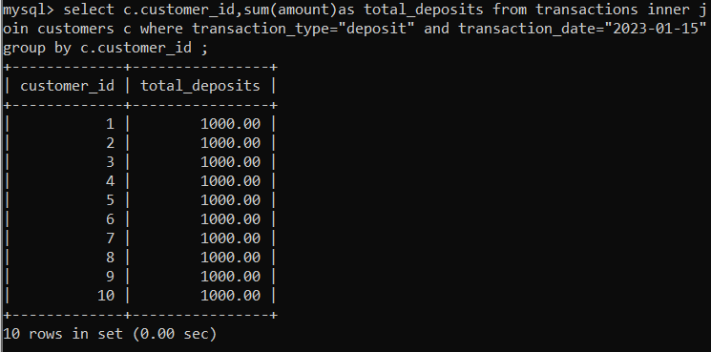

4. Find the Oldest and Newest Customers.

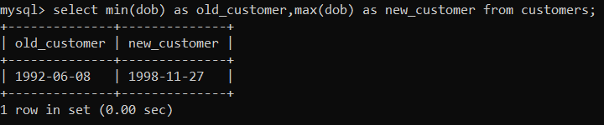

5. Retrieve transaction details along with the account type.

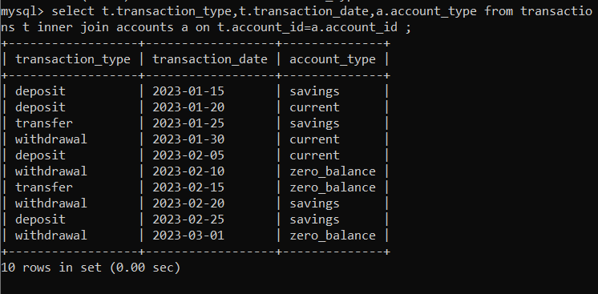

6. Get a list of customers along with their account details.

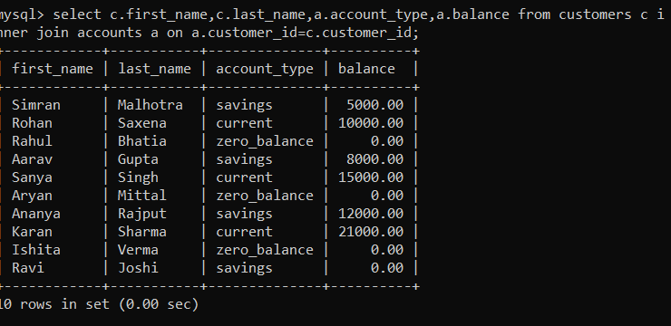

7. Retrieve transaction details along with customer information for a specific account.

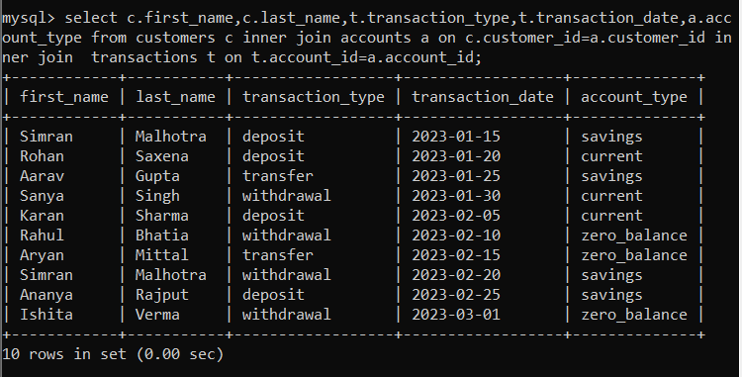

8. Identify customers who have more than one account.



9. Calculate the difference in transaction amounts between deposits and withdrawals.

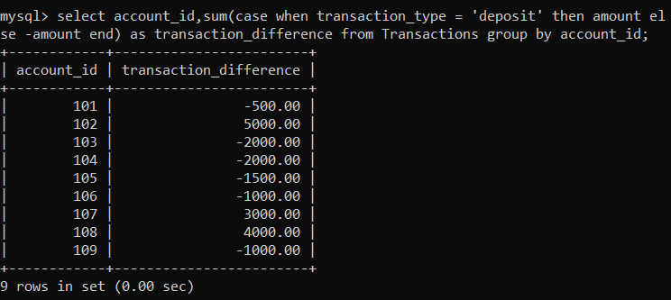

10. Calculate the average daily balance for each account over a specified period

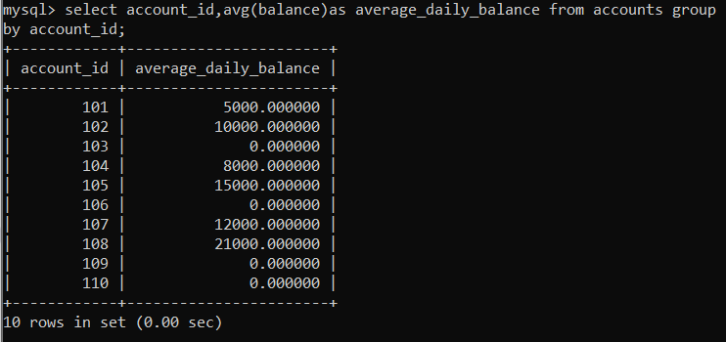

11. total balance for each account type

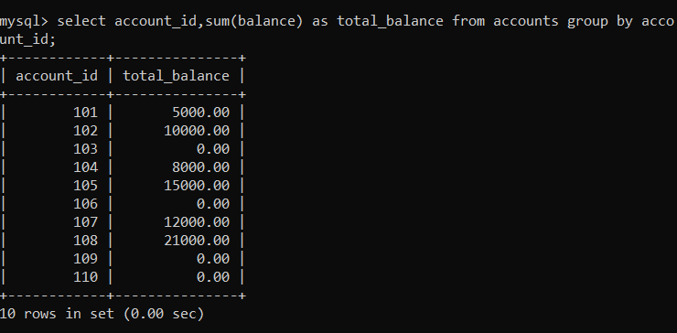

12. Identify accounts with the highest number of transactions order by descending order

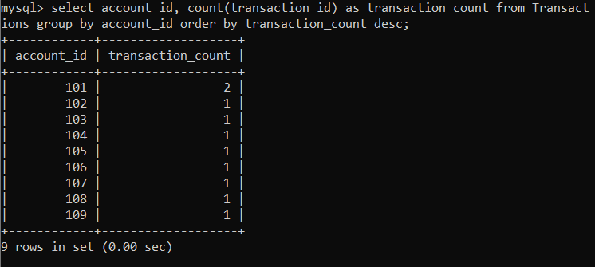

13. List customers with high aggregate account balances, along with their account types.

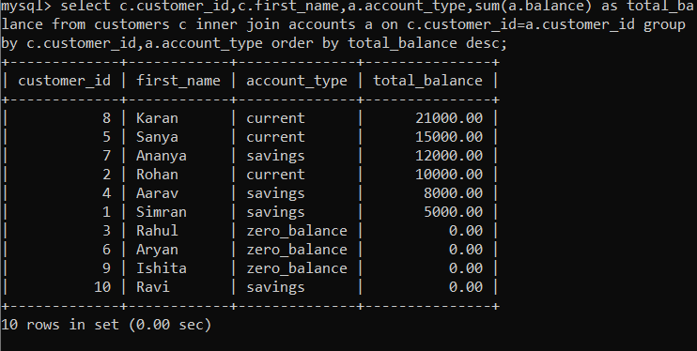

14. Identify and list duplicate transactions based on transaction amount, date, and account.

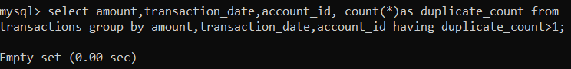

TASK 4

1. Retrieve the customer(s) with the highest account balance.

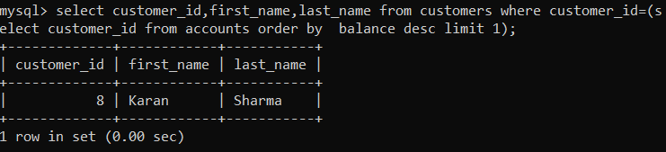

2. Calculate the average account balance for customers who have more than one account.

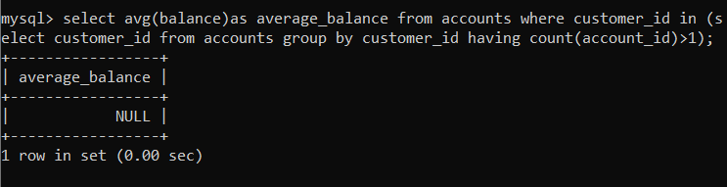

3. Retrieve accounts with transactions whose amounts exceed the average transaction amount.

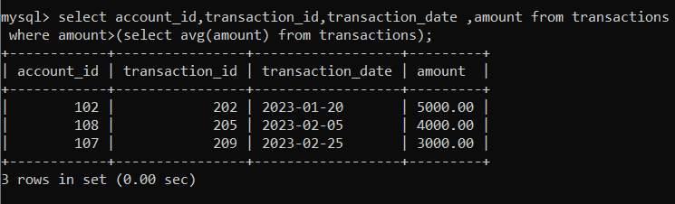

4. Identify customers who have no recorded transactions.

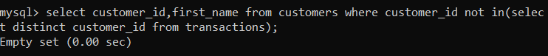

5. Calculate the total balance of accounts with no recorded transactions.

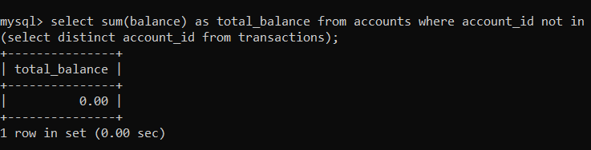

6. Retrieve transactions for accounts with the lowest balance.

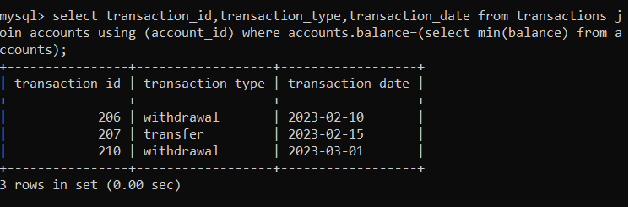

7. Identify customers who have accounts of multiple types.

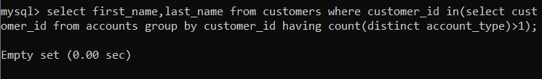

8. Calculate the percentage of each account type out of the total number of accounts.

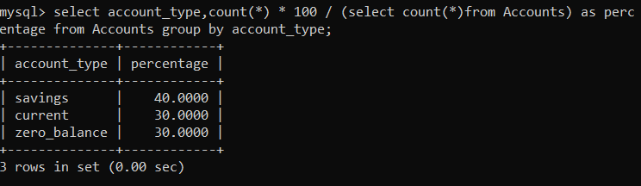

9. Retrieve all transactions for a customer with a given customer_id.

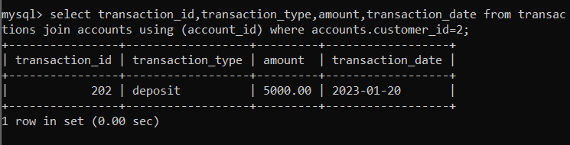

10. Calculate the total balance for each account type, including a subquery within the SELECT clause

